Karol Wadolowski

ECE 408: Wireless Communications

Project #0 – Warm Up

Introduction

The goal of this assignment was to check if we are adequately prepared for the course. The assignment was the final project for Prof. Keene’s 2015 Communication Systems Course. It consists of two parts. In the first part the skeleton script provided must be extended to work for 4 and 16 QAM modulation. After extending the script we must simulate the affects of an AWGN with no ISI interference using various QAM sizes and confirm that it matches with the theoretical curves. Afterwards switch to the moderate ISI channel and use equalization to achieve a specified BER. The second part of the project asks us to reach a lower BER on the moderate ISI channel using whatever means possible (without inverting the channel directly).

Part 1

The skeleton was first expanded to allow for higher order QAM. This was done by first extending the bit generation to symbol generation in effect. The rest of the code for finding the simulated BER curves was left in essence. The major change occurred in calculating the theoretical QAM BER curves. In the original code the berawgn function took as an argument (SNRdB + 3). Where does the 3 come from? Why does it work for one case but not all cases? This +3 was here since the berawgn function is supposed to be supplied EbNo values. For BPSK with no ISI this should be the same, but due to the way awgn function adds noise to BPSK (real noise instead of complex) this lead to an inconsistency. The real to complex noise difference corresponds to a factor of 2 in linear terms which corresponds to 3 dB ≈ 10\*log10(2). More generally the conversion from SNR to EbNo for M QAM is

EbNo dB = SNR dB - 10\*log10(log2(M)) which corresponds to dividing the signal power by the number of bits per symbol. Doing this makes the theoretical and simulated BER and SER curves match for all rectangular QAMs (Figure 1). The theoretical and simulated curves match. approximately for non-rectangular QAM but not exactly. I believe this is due to how the berawgn function approximates the corners for non-square QAM.

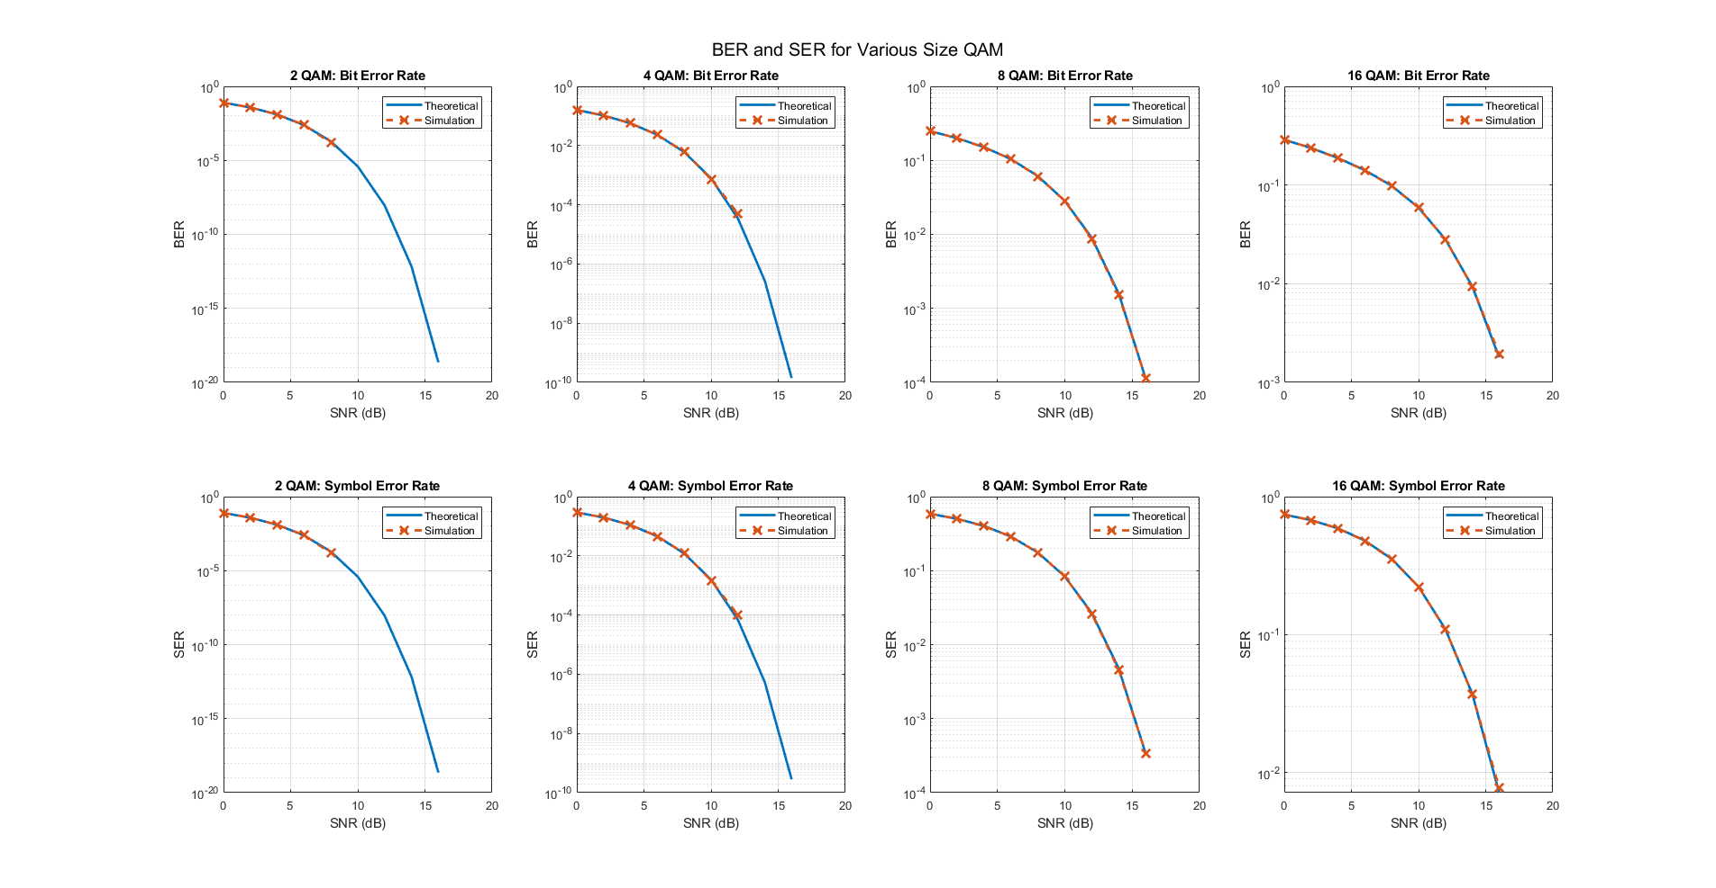

Figure 1: Top row: theoretical and simulated BER curves for 2, 4, 8, and 16 QAM. Bottom row: theoretical and simulated SER curves for the same QAM constellations. (They match!)

At this point the moderate ISI channel was used and a BER of 1e-4 at an SNR of 12 dB had to be obtained using channel equalization. In order to do this a decision feedback equalizer (DFE) was added. The DFE used 1 feedforward tap and 2 feedback taps. It also used 100 training samples and the LMS algorithm to adjust the tap weights. The results of this equalization can be seen in Figure 2. In Figure 2, the theoretical and simulated BPSK BER curves (blue and orange) for a no ISI channel are displayed for comparison. The BER curve for the moderate ISI channel with no equalization is also shown (yellow) so that the improvement of equalization can be appreciated. The equalized BER version (purple) shows significant improvement over an unequalized channel. At 10 dB it is already meeting the required BER. Note that training samples were not counted in the BER calculation.

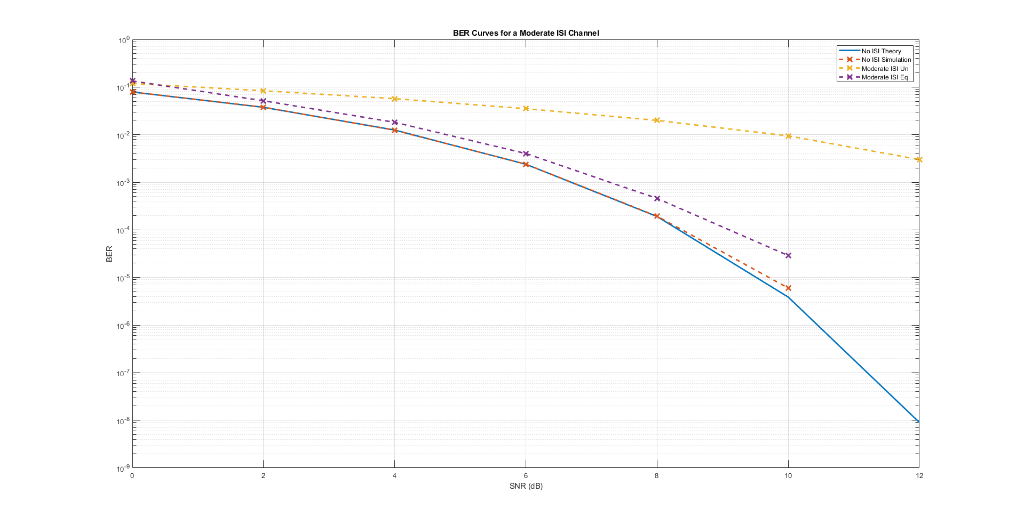

Figure 2: Performance improvement from DFE in a moderate ISI channel.

Part 2

The goal of this section was to reach a BER of 1e-6 at an SNR of 12 dB in a moderate ISI channel using any means possible. To do this a rate ½ error correction code was applied. The code in question is a convolutional code with generators g(0) = (101 110 001) = 561 and

g(1) = (111 101 011) = 753. This code was taken from “Error Control Systems for Digital Communication and Storage” – Wicker. This specific code was chosen for its lower constraint length and relatively high minimum free distance of 12 which helps in its error correction capabilities. Other error correction codes such as turbo or LDPC could have been used instead. Since I was using a rate ½ convolutional encoder I decided to use 4 QAM as then each output of the encoder gets mapped to its own symbol. Using this method and the DFE from before, except this time with 300 training samples, a BER of around 3e-7 was achieved at an SNR of 12 dB as can be seen in Figure 3. Again, the ECC and equalized 4 QAM (orange) is compared to no ISI BPSK.

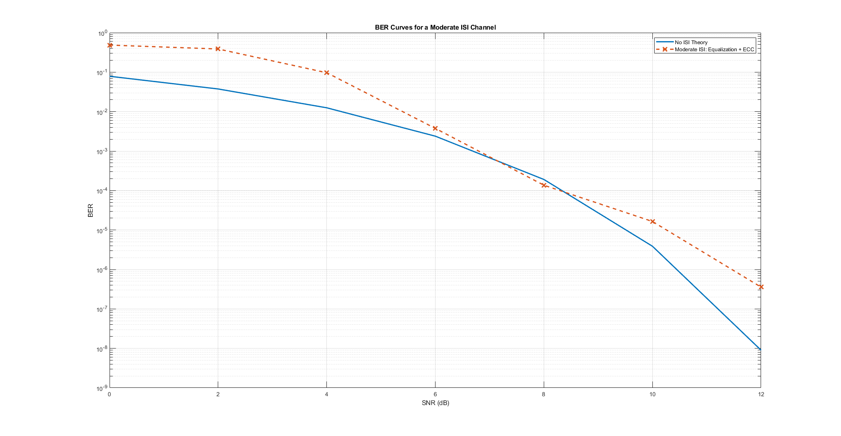

Figure 3: Performance of 4 QAM with an equalizer and ECC in a moderate ISI channel (orange) compared to the theoretical no ISI BPSK BER curve (blue).

Conclusion

Throughout the course of this project essential ideas in communications systems were refreshed. Another thing that was dug up from the older memories was a quote from Professor Fontaine. It goes like this “Don’t use the built in awgn function. You don’t how it works and you will use it incorrectly!” This happened to me because the function decides to handle the BPSK case differently. Always make sure you know how the function works! It will save you a ton of time.